ECA1803 – OPTOELECTRONICS AND OPTICAL COMMUNICATION
CO1 ENGINEERING DESIGN ASSIGNMENT REPORT

PRESENTED BY:
A.M.VISHAL (192412079)

GUIDED BY :
Dr.Princy Magdaline Paramanantham

Executive Summary
An 8-channel, 100 GHz-spaced, 25 Gb/s NRZ link over 6 × 80 km of SMF is best served by an InP monolithic 8-λ DFB-laser + electro-absorption-modulator (EML) array with an on-chip AWG multiplexer, ITUgrid locked, on a TEC held to ±0.1 °C with an etalon wavelength locker. The DFB gives λ = 1.55 µm, η_{int} = 0.80, P = 8.4 mW (9.24 dBm), f_{3dB} = 20 GHz against a 17.5 GHz NRZ requirement (2.5 GHz margin). External modulation is chosen because direct modulation chirp is incompatible with 25 Gb/s over 80 km spans. The uncontrolled 4.0 nm drift (= 5 channel slots) forces TEC control (±1 °C minimum). The calculated SBS threshold (1.59 mW) is below the given 2 mW launch and the 16 mW total exceeds a +10 dBm eye-safety reference, so the adopted launch is 1 mW (0 dBm) per channel (8 mW total = 9.03 dBm), which still leaves ≈ 12 dB OSNR margin. SRS (1.01 W) is negligible. Soliton transmission is not feasible (L_{D} = 11.25 km, N = 0.171, requires 68.4 mW peak); digital back-propagation is not appropriate for an IM-DD 8-channel link.
Decision: YES – deploy, subject to the stated conditions.

Table 0. Key results at a glance
Quantity | Result | Quantity | Result
Emission wavelength | 1.550 µm | Internal quantum efficiency | 0.80 (τ = 8 ns)
Output power (I =  40 mA) | 8.4 mW = 9.24 dBm | NRZ bandwidth / margin | 17.5 GHz / 2.5  GHz (14.3 %)
Drift (ΔT = 40 °C) | 4.0 nm = 5 × 0.8 nm | Required TEC stability | ±1 °C (design  ±0.1 °C)
L_{eff} (80 km) | 21.17 km | φ_{NL} per span / 6 spans  (2 mW) | 0.055 / 0.330 rad
P_{th}(SBS) / P_{th}(SRS) | 1.59 mW / 1.01 W | Total launch (8 × 2  mW) | 16 mW = 12.04 dBm
L_{D} / L_{NL} (2 mW) | 11.25 km / 384.6 km | Soliton order N | 0.171 →  infeasible

Notation and Assumptions
Every parameter not given in the problem statement is listed below so that all calculations are reproducible.
Where the printed PDF had a garbled exponent (g_{R}), the standard silica value was used.

No. | Assumption | Value / Basis
A1 | Speed of light, Planck relation | c = 2.998 × 10⁸ m/s; λ(µm) = 1.24 / E_{g}(eV)
A2 | Raman gain coefficient (print garbled) | g_{R} = 6 × 10⁻¹⁴ m/W (silica, peak)
A3 | Fiber dispersion (SMF-28 at  1550 nm) | D = 17 ps/(nm·km); |β₂| ≈ 21.7 ps²/km (the given  20 ps²/km is used for the soliton calculation)
A4 | Brillouin gain bandwidth | Δν_{B} ≈ 20 MHz (Brillouin shift ≈ 11 GHz)
A5 | Eye-safety reference (ANSI  Z136.2 / IEC 60825-1) | Class-1 aggregate limit at 1550 nm ≈ 10 mW  (+10 dBm) at an open connector, 10 s exposure
A6 | Amplifier and receiver | EDFA noise figure 5 dB; span loss = 0.2 × 80 =  16 dB; required OSNR ≈ 17 dB/0.1 nm for 25  Gb/s NRZ (pre-FEC)
A7 | Chirp parameters | α_{H} ≈ 4 (directly modulated DFB); α_{H} ≈ 0–1  (EAM/MZM)
A8 | Current tuning coefficient of a  DFB | ≈ 0.005 nm/mA (typical 0.003–0.01 nm/mA)
A9 | Electrical operating point | Forward voltage V_{f} ≈ 1.5 V at 40 mA (for wallplug efficiency)
A10 | Per-channel bandwidth of the loss budget | EAM insertion loss 3.5 dB; AWG + coupling  2.7 dB (typical InP PIC values)

STAGE 1 – Interpret the Communication Requirement

1.1 Working backward from the system requirement
The requirement fixes five derived system numbers before any device is chosen:Channel spacing: Δλ = λ²Δf
/ c = (1550 nm)²(100 GHz)/(2.998×10⁸ m/s) = 0.80 nm
Aggregate capacity = 8 × 25 Gb/s = 200 Gb/s; spectral efficiency = 25 Gb/s / 100 GHz = 0.25 b/s/Hz
Reach = 6 × 80 km = 480 km; span loss = 0.2 dB/km × 80 km = 16 dB per span
Accumulated dispersion = D·L = 17 ps/(nm·km) × 480 km ≈ 8160 ps/nm (bit period T_{b} = 40 ps)
Signal bandwidth B ≈ 0.7 R_{b} = 17.5 GHz (17.5 % of the 100 GHz slot)
These numbers drive every requirement: a 1550 nm source is needed to sit on the minimum-loss window and in the EDFA gain band; the 17.5 GHz signal occupies 0.14 nm of a 0.8 nm slot, so any source line or sidemode wider or stronger than a few tenths of a nanometre spills into neighbouring channels; 8160 ps/nm of dispersion is 204 bit periods per nm of signal bandwidth, so chirp and linewidth cannot be ignored; and six cascaded EDFAs make ASE accumulation (OSNR) and, conversely, nonlinearity (launch power) both critical. 1.2 Why the source needs speed, narrow linewidth and power
Requirement | Reason (link-specific) | Controlling source quantity
High modulation speed | 25 Gb/s NRZ needs B ≈ 17.5 GHz; the source (or modulator) 3 dB bandwidth must exceed it with margin for ISI and eye opening. | f_{3dB}, relaxationoscillation frequency f_{r}, damping, parasitics
Narrow  linewidth /  high SMSR | Slot width is 0.8 nm; the optical spectrum after modulation (≈ 0.4 nm main lobe) plus any chirp must stay inside the slot. Narrow line limits dispersion-induced pulse spreading over 8160 ps/nm and limits crosstalk from side modes (SMSR ≥ 30 dB, G.957). | Δν (Schawlow–Townes × (1+α_{H}²)), SMSR, mode-partition noise
High output power | Each 80 km span loses 16 dB; six EDFAs add ASE. OSNR ≈ 58 + P_{ch} − 16 − NF − 10log N: more launch power raises OSNR dB-for-dB until nonlinearity and safety limits intervene. | P = η_{s}(I−I_{th}), η_{ext}, coupling loss

1.3 Source characteristics that set wavelength, efficiency and spectral purity
- Bandgap E_{g} sets the emission wavelength λ = 1.24/E_{g}; with 0.80 eV, λ = 1.55 µm (C-band).
- Quantum efficiency η_{int} = τ_{nr}/(τ_{r}+τ_{nr}) is the fraction of carriers recombining radiatively; η_{ext} (differential) = η_{s}·q/(hν) sets wall-plug efficiency.
- Threshold current I_{th} and slope efficiency η_{s} set power at a given bias and the bias needed for fast response (turn-on delay vanishes when I_{b} > I_{th}).
- Linewidth and SMSR are set by the cavity: DFB/DBR gratings select one longitudinal mode (SMSR > 35 dB), FP cavities support many.

1.4 Modulation, chirp and temperature quantities to be controlled
- Bias-to-threshold ratio (I/I_{th} = 3.33) and relaxation-oscillation frequency f_{r} √(I/I_{th}−1); damping factor; extinction ratio.
- Chirp parameter α_{H}, transient chirp Δν = (α_{H}/4π)(1/S)(dS/dt) and adiabatic chirp; their interaction with D·L.
- Wavelength temperature coefficient 0.1 nm/°C (≈ 12.5 GHz/°C), TEC stability, wavelength-locker accuracy, ageing drift.

1.5 Nonlinear-transmission quantities
With 8 channels, 6 spans and several mW of total power, the quantities that matter are: effective length L_{eff} = 21.17 km; nonlinear coefficient γ = 1.3 W⁻¹km⁻¹; per-channel and total launch power (2 mW and 16 mW); phase shift φ_{NL} = γPL_{eff}; walk-off length and phase-mismatch Δβ D·Δf² (governing XPM and FWM); and the SBS/SRS thresholds, which scale as A_{eff}/(g·L_{eff}).

1.6 Role of the standards
Standard | What it defines for the transmitter
ITU-T G.957 (SDH optical interfaces) | Mean launched power range, central wavelength range, maximum spectral width / −20 dB width, minimum SMSR (30 dB), minimum extinction ratio, eye-mask, maximum reflectance and dispersion/path-penalty (≤ 1 dB). (DWDM frequency grid itself comes from ITU-T G.694.1 – assumed companion reference.)
IEEE 802.3bm / 802.3bs  (40/100 and 200/400  GbE) | Per-lane 25.78 GBd NRZ (or 26.56 GBd PAM4) optical specs:  average launch power, OMA_{outer}, TDP/TDECQ, extinction ratio, SMSR ≥ 30 dB, RIN₂₀OMA, wavelength windows, receiver sensitivity and return-loss tolerance.
ANSI Z136.2 (with IEC  60825-1/-2) | Safe use of fiber-optic communication systems: hazard/class limit of accessible optical power at 1550 nm, automatic power reduction (APR) and open-fibre control, labelling.

1.7 System parameters affecting soliton/DSP compensation and integration
Soliton propagation depends on T₀, β₂, γ and peak power through L_{D} = T₀²/|β₂| and L_{NL} = 1/(γP₀); it also needs amplifier spacing  L_{D}. Digital back-propagation (DBP) requires access to the complex optical field (coherent receiver), knowledge of the link parameters and, for multi-channel DBP, joint processing of all channels. The integration decision depends on footprint, power dissipation, chip-to-fibre coupling loss (which directly reduces launch power), reliability and scalability to more channels.

1.8 Characteristics of an acceptable transmitter
An acceptable transmitter must: (i) emit on the 1550 nm ITU grid; (ii) provide f_{3dB} ≥ 17.5 GHz with positive margin; (iii) have narrow linewidth, SMSR ≥ 30 dB and low chirp; (iv) deliver adequate but safe launch power (OSNR margin without exceeding SBS or the eye-safety limit); (v) keep wavelength inside ±0.1 nm over a 40 °C ambient change; (vi) meet G.957/802.3bs/bm parameters; and (vii) be compact, efficient and scalable.
PROBLEM REQUIREMENT STATEMENT. The proposed transmitter must generate eight single-mode, low-chirp, 25 Gb/s NRZ optical carriers centred on the 100 GHz ITU grid near 1550 nm, each locked within ±0.1 nm over a 40 °C ambient variation, with ≥ 17.5 GHz usable modulation bandwidth and SMSR ≥ 30 dB; deliver a per-channel launch power that gives ≥ 17 dB OSNR after six 80 km amplified spans while staying below the SBS threshold, with SPM/XPM/FWM penalties controlled; keep the aggregate launched power within the ANSI Z136 / IEC 60825-1 eye-safety reference (+10 dBm); comply with ITU-T G.957 and IEEE 802.3bs/bm transmitter parameters; and be implemented in a compact, power-efficient, scalable integrated form. Soliton propagation depends on T₀, β₂, γ and peak power through L_{D} = T₀²/|β₂| and L_{NL} = 1/(γP₀); it also needs amplifier spacing  L_{D}. Digital back-propagation (DBP) requires access to the complex optical field (coherent receiver), knowledge of the link parameters and, for multi-channel DBP, joint processing of all channels. The integration decision depends on footprint, power dissipation, chip-to-fibre coupling loss (which directly reduces launch power), reliability and scalability to more channels.

STAGE 2 – Investigate and Select the Optical Source

2.1 Recombination processes and the role of the bandgap
Electrons injected into the active region recombine by (a) radiative recombination (band-to-band photon emission, rate 1/τ_{r}, desired), and (b) non-radiative recombination (Shockley–Read–Hall defect recombination, Auger recombination and surface/interface recombination, rate 1/τ_{nr}, producing heat). The photon energy is set by the bandgap of the active layer, hν ≈ E_{g}; in InGaAsP/InP the composition is chosen to place E_{g} at the required wavelength.
Emission wavelength: λ ≈ 1.24 / E_{g} = 1.24 µm·eV / 0.80 eV = 1.55 µm = 1550 nm (centre of the Cband, minimum fiber loss 0.2 dB/km, EDFA gain window).
Total carrier lifetime: 1/τ = 1/τ_{r} + 1/τ_{nr} = 1/10 ns + 1/40 ns = 0.125 ns⁻¹ → τ = 8 ns.
Internal quantum efficiency: η_{int} = (1/τ_{r}) / (1/τ_{r}+1/τ_{nr}) = τ_{nr}/(τ_{r}+τ_{nr}) = 40/(10+40) = 0.80 (80 %).
Differential (external) efficiency: η_{d} = η_{s}·(q/hν) = (0.3 mW/mA) / (0.80 V) = 0.375 (37.5 %); wallplug efficiency at 40 mA: P/(I·V_{f}) = 8.4 mW / (40 mA × 1.5 V) = 14 % (A9).

2.2 Threshold condition for laser oscillation
Oscillation begins when round-trip gain equals round-trip loss. For an FP cavity of length L with facet
reflectivities R₁, R₂:
Γ g_{th} = α_{int} + (1/2L) ln(1/(R₁R₂)) → I_{th} = q V N_{th} / (η_{i} τ)
For a DFB, the distributed feedback grating (coupling coefficient κ) replaces the facet mirrors: the Bragg condition λ_{B} = 2n_{eff}Λ/m selects one mode, and the threshold gain is set by κL (typically κL ≈ 1–2), with a λ/4 phase shift or asymmetric facet coatings to enforce single-mode operation. Above threshold the output follows P = η_{s}(I − I_{th}) with I_{th} = 12 mA for the candidate device.

2.3 Linewidth, SMSR and their effect on an 8-channel DWDM link
- Linewidth Δν = R_{sp}(1+α_{H}²)/(4πS): the (1+α_{H}²) enhancement is why low-α_{H} sources (QD, EAMmodulated) have narrower lines. A narrow line keeps the modulated spectrum inside 0.8 nm, minimises dispersion-induced broadening (ΔT = D·L·Δλ) and, in a CW/low-modulation case, determines the SBS threshold (Stage 4).
- SMSR (side-mode suppression ratio): side modes sit at 1.1 nm (FP) or a few nm (DFB stop-band edge) away. With SMSR = 35 dB a side mode is 0.03 % of the main-mode power; with 8 channels × 7 neighbours the aggregate in-band crosstalk must stay  −25 dB, so SMSR ≥ 30 dB (G.957 / 802.3) is mandatory. A multimode FP (SMSR < 5 dB, Δλ ≈ 3–5 nm) puts ≥ 4 comb lines inside neighbouring slots and cannot be used.
- Mode-partition noise in FP lasers combines with chromatic dispersion to give an unavoidable BER floor over 480 km.
2.4 Comparison of candidate sources

Table 2. Comparison of LED, FP, DBR, DFB, VCSEL and QD sources (typical 1550 nm values)
Parameter | LED | FP laser | DBR  laser | DFB laser | VCSEL  (1550) | QD laser
Fibrecoupled power | −20 to  −10 dBm (0.01–0.1  mW) | 1–10 mW | 5–20 mW | 5–20 mW | 0.5–3  mW | 5–15 mW
Spectral width | 70–100 nm | 1–5 nm  (multimode) | 1–10  MHz line | 1–5 MHz  line (Δλ < 0.1 nm) | ≈ 0.1 nm  (SM) | 0.1–1  MHz (low  α_{H})
SMSR | n/a | < 5 dB | > 35 dB | 35–50 dB | 30–40 dB | > 35 dB
Modulation speed | 0.05–0.5  GHz | 5–15 GHz | 5–15  GHz | 15–30  GHz  (DML), >30 GHz as EML | 10–25  GHz | 10–25  GHz
Threshold | none | 10–20 mA | 20–40 mA | 8–20 mA | 1–5 mA | 5–10 mA
Efficiency | low (η_{d} <  5 %) | moderate | moderate | η_{d} ≈ 30–40  % | high WPE, low power | moderate– high
Temp.  sensitivity | ≈ 0.3 nm/°C  (broad) | ≈ 0.4 nm/°C (mode hops) | 0.1 nm/°C + hops | 0.1 nm/°C | 0.1  nm/°C | Very low  T₀ sensitivity
Fibre coupling | poor (< 5  %) | good | good | good  (SSC) | excellent  (circular beam) | good
DWDM  suitability | unsuitable | unsuitable | good  (tunable) | best /  mature | short reach | promising  / immature

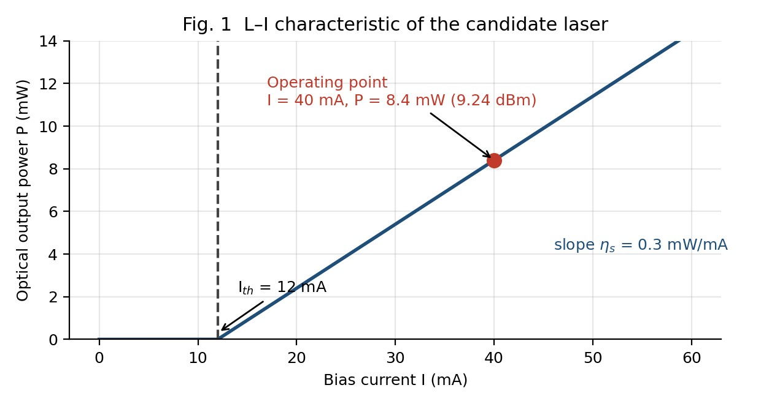
Fig. 1 L–I characteristic: I_{th} = 12 mA, η_{s} = 0.3 mW/mA, operating point 8.4 mW at 40 mA.
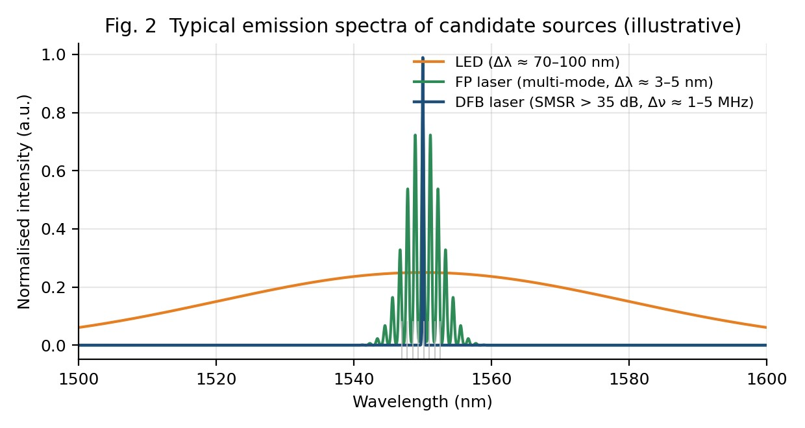
Fig. 2 Typical emission spectra: the LED covers all 8 channels, the FP laser several, the DFB only one
channel slot (illustrative).

2.5 Weighted decision matrix
Scores (1 = poor, 5 = excellent) are weighted by importance to this application: spectral purity 30 %, modulation speed 20 %, output power 15 %, wavelength/temperature stability 15 %, maturity-coupling-cost 20 %.
Source | Spectral  (0.30) | Speed  (0.20) | Power  (0.15) | Stability  (0.15) | Maturity  (0.20) | Weighted score
LED | 1 | 1 | 1 | 2 | 3 | 1.55
FP | 2 | 3 | 4 | 3 | 5 | 3.25
DBR | 4 | 3 | 4 | 3 | 3 | 3.45
Source | Spectral  (0.30) | Speed  (0.20) | Power  (0.15) | Stability  (0.15) | Maturity  (0.20) | Weighted score
DFB | 5 | 4 | 4 | 4 | 5 | 4.50
VCSEL | 4 | 4 | 2 | 3 | 3 | 3.35
QD | 5 | 4 | 4 | 5 | 2 | 4.05

DESIGN DECISION 1. I recommend a 1550 nm InGaAsP/InP DFB laser (one per channel, in an array with external modulators) optical source because: (1) λ = 1.24/0.80 = 1.55 µm sits exactly on the Cband/EDFA window; (2) η_{int} = 0.80 and η_{d} = 37.5 % give P = 8.4 mW (9.24 dBm) at only 40 mA; (3) a single longitudinal mode with SMSR > 35 dB and MHz-class linewidth keeps each channel inside its 0.8 nm slot, which LED (≈ 70–100 nm) and FP (several nm, multimode) cannot do; (4) f_{3dB} = 20 GHz exceeds the 17.5 GHz NRZ bandwidth and the DFB is natively compatible with integrated EAM/MZM external modulation; and (5) it has the highest weighted score (4.50) and the most mature manufacturing and reliability record.

2.6 Credible alternative and the condition under which it becomes preferable
The quantum-dot (QD) laser (weighted score 4.05) is the technically credible alternative. Its low α_{H} (≈ 0– 1), very low linewidth, high characteristic temperature T₀ and low threshold make it preferable (a) if the transmitter must operate uncooled or over a wide case-temperature range (drift and TEC power would shrink), (b) if a single QD mode-locked comb laser can replace eight DFBs (inherently equal 100 GHz spacing, lower FWM-free planning) and (c) if the link is upgraded to coherent or higher-order modulation where linewidth and chirp dominate. It is not selected today because 1550 nm QD/QDash material is less mature .

STAGE 3 – Modulation, Chirp and Spectral-Stability Strategy

3.1 Output power
P = η_{s}(I − I_{th}) = 0.3 mW/mA × (40 − 12) mA = 0.3 × 28 = 8.4 mW
P(dBm) = 10 log₁₀(8.4 mW / 1 mW) = 10 × 0.9243 = 9.24 dBm
The bias is I/I_{th} = 40/12 = 3.33, i.e. well above threshold, which (a) removes turn-on delay, (b) raises the relaxation-oscillation frequency and (c) reduces the relative intensity noise.

3.2 Bandwidth requirement and margin
B ≈ 0.7 R_{b} = 0.7 × 25 Gb/s = 17.5 GHz
Margin = f_{3dB} − B = 20 − 17.5 = 2.5 GHz (= 2.5/17.5 = 14.3 %; f_{3dB}/B = 1.14)
The 20 GHz device is therefore sufficient, but the margin is thin: package/driver parasitics, bond-wire inductance and temperature (f_{3dB} falls roughly 1 %/°C as gain compression increases) can consume it. If the 25.78 GBd line rate of IEEE 802.3bm lanes is used, B = 0.7 × 25.78 = 18.05 GHz and the margin falls to 1.95 GHz (10.8 %), still positive. An external EAM/MZM (> 30 GHz bandwidth) removes this dependence altogether.

3.3 Rate equations and relaxation oscillation
The coupled carrier density N(t) and photon density S(t) rate equations for a single-mode laser are:
dN/dt = I/(qV) − N/τ_{s} − v_{g} g(N) S dS/dt = Γ v_{g} g(N) S − S/τ_{p} + Γ β N/τ_{r}
where g(N) = a(N − N₀) is the gain (with gain compression g/(1+εS)), τ_{s} the carrier lifetime, τ_{p} the photon lifetime, Γ the confinement factor and β the spontaneous-emission factor. Linearising about the bias point gives a damped second-order system whose resonance is the relaxation-oscillation frequency
f_{r} = (1/2π) √( v_{g} a S₀ / τ_{p} ) ≈ (1/2π) √( (I/I_{th} − 1) / (τ_{p} τ_{s}) )
Numerically, I/I_{th} − 1 = 2.33. The given f_{3dB} = 20 GHz corresponds to f_{r} ≈ 13–14 GHz (f_{3dB} ≈ 1.55 f_{r} for light damping, f_{r} = 12.9 GHz; f_{r} ≈ 14 GHz for the moderately damped response plotted in Fig. 3). Taking f_{r} = 14.1 GHz gives τ_{p}τ_{s} = 2.33/(2π × 14.1×10⁹)² = 2.97×10⁻²² s², e.g. τ_{p} ≈ 1 ps and an effective τ_{s} ≈ 0.3 ns – realistic for a DFB. Because f_{r} √(I − I_{th}), cutting the bias to 25 mA would reduce f_{r} to 14.1 √(13/28) ≈ 9.6 GHz, below the NRZ requirement – hence the high 40 mA bias.
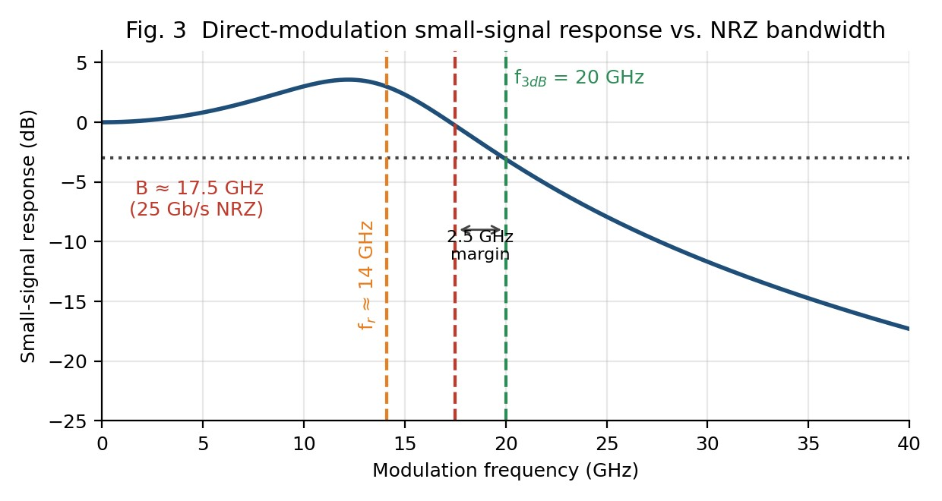
Fig. 3 Small-signal modulation response of the DFB (f_{r} ≈ 14 GHz, f_{3dB} = 20 GHz) and the 17.5 GHz NRZ

requirement; margin = 2.5 GHz. Table 3. Small-signal versus large-signal modulation
Aspect | Small-signal modulation | Large-signal (NRZ) modulation
Drive | Small sinusoidal current ΔI  I −  I_{th}; linearised equations valid | Current switched between I₀ (“0”) and  I₁ (“1”) – nonlinear equations
Result | Frequency response H(f) = f_{r}²/(f_{r}²  − f² + jfγ/2π); resonance peak at f_{r} | Turn-on delay, overshoot and ringing at ≈ f_{r}; pattern-dependent jitter; eye closure
Effective f_{r} | f_{r} set by the bias S₀ | f_{r} depends on instantaneous S: lower in the “0” level (low S), higher in “1” – ringing frequency varies
Chirp | Small, sinusoidal | Large transient chirp (α_{H}/4π)(dlnS/dt) at each edge + adiabatic chirp between levels
Design consequence | Defines f_{3dB} (20 GHz) | Requires I₀ > I_{th} (no turn-on delay), limited extinction ratio, driver preemphasis

3.4 Direct versus external modulation
For a directly modulated laser the carrier-density variation modulates the refractive index, producing a frequency chirp: Δν(t) = (α_{H}/4π)[ (1/S)dS/dt + κS ]. With α_{H} ≈ 4 (A7) and a 20 ps edge (0.35/17.5 GHz), the transient chirp is of the order of 10–20 GHz, i.e. Δλ_{chirp} ≈ λ²Δν/c ≈ 0.13 nm for Δν = 16 GHz. Acting on D =
17 ps/(nm·km) this spreads pulses by ΔT = D·L·Δλ = 17 × 80 × 0.13 ≈ 174 ps per span, more than four bit periods (40 ps). An externally modulated source (EAM: α_{H} ≈ 0–1, dual-drive MZM: α_{H} ≈ 0) keeps the line narrow and its pulses nearly transform-limited, so that the accumulated dispersion is deterministic and can be removed by a DCM or by receiver equalisation.
Dispersion-limited length (1 dB penalty, NRZ, transform-limited): L ≈ 104 000 / (D B²) = 104 000 / (17 × 25²) ≈ 9.8 km; chirped DML: ≈ 1–2 km.
Both options therefore need dispersion compensation for 80 km spans (D·L = 1360 ps/nm per span) – but only external modulation leaves a clean, compensable signal. Direct modulation is only acceptable for the unamplified reach of ≲ 2 km.

Table 4. Direct versus external modulation for this link
Criterion | Direct modulation (DML) | External modulation  (EAM/MZM)
Chirp (α_{H}) | High (≈ 3–5), transient + adiabatic | Low (EAM 0–1; dual-drive MZM ≈  0)
Bandwidth | Limited by f_{r}/damping (20 GHz here → 2.5 GHz margin) | > 30 GHz (EAM/TW-MZM),  independent of laser dynamics
Dispersion interaction | Chirp × D·L → pulse  broadening/compression, penalty >  2 dB beyond ≈ 2 km | Transform-limited; penalty removable by DCM/EDC
Useful distance at 25  Gb/s | ≈ 1–2 km (uncompensated) | ≈ 10 km uncompensated; 480 km with DCM/EDC and EDFAs
Power, cost, complexity | Highest wall-plug efficiency, lowest cost | EAM insertion loss ≈ 3–4 dB, extra driver; cost offset by monolithic integration
Extinction ratio | Limited (turn-on, I > I_{th}) | ≥ 8–10 dB achievable (G.957 /  802.3 satisfied)

3.5 Wavelength drift, TEC and current tuning
Uncontrolled drift: Δλ = (dλ/dT) ΔT = 0.1 nm/°C × 40 °C = 4.0 nm
Compared with spacing: 4.0 nm / 0.8 nm = 5 channel spacings (a channel would drift into the slot of the 5th neighbour) – and 4.0 nm ≫ ±0.1 nm tolerance (40×).
Required temperature stability: ΔT_{max} = Δλ_{tol} / (dλ/dT) = 0.1 nm / (0.1 nm/°C) = ±1 °C

A ±1 °C error budget would consume the whole ±0.1 nm tolerance, leaving nothing for locker error and ageing. The design therefore allocates TEC stability ±0.1 °C (±0.01 nm), an etalon-locker error of ±0.03 nm and ageing drift of ±0.03 nm: root-sum-square < ±0.05 nm, i.e. half the permitted tolerance.
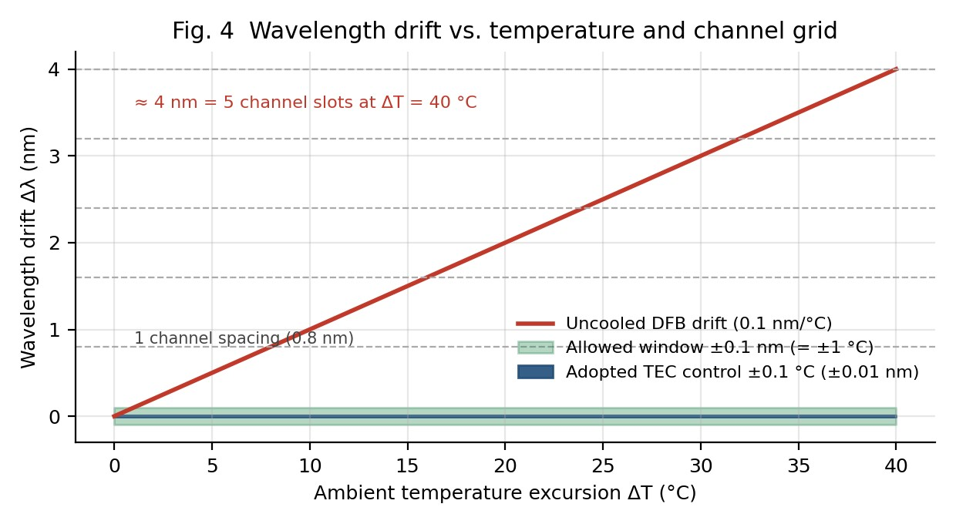
Fig. 4 Wavelength drift versus temperature: uncooled 4 nm (5 slots) versus the ±0.1 nm window and the

adopted ±0.1 °C TEC control. Table 5. TEC control versus injection-current control
Criterion | TEC (thermal) control | Injection-current tuning
Tuning rate | 0.1 nm/°C (≈ 12.5 GHz/°C) | ≈ 0.005 nm/mA (A8), via selfheating + carrier effect
Range needed to cancel 4 nm | 40 °C – easily within TEC range | ≈ 800 mA – impossible (exceeds device rating)
Side effects | None on power or chirp; slow (ms–s), which is fine for ambient drift | Changes output power (0.3 mW/mA): ±0.1 nm ≈ ±20 mA ≈ ±6 mW (±70 % of 8.4 mW); alters chirp, f_{r} and RIN
Resolution / stability | ±0.1 °C with NTC + PID loop | Fast, fine, but couples to the data bias
Role in design | Primary coarse + fine control | Not used; only optional trim via micro-heater/phase section

DESIGN DECISION 2. I recommend external (EAM/MZM) modulation of a CW-biased DFB and TECbased temperature control with a closed-loop etalon wavelength locker (±0.1 °C) because: the laser delivers 8.4 mW (9.24 dBm), which after the EAM (−3.5 dB) and AWG/coupling (−2.7 dB) still gives ≈ +3 dBm, so power is adequate; the 20 GHz laser bandwidth gives only 2.5 GHz (14.3 %) margin whereas the external modulator removes this limit; direct-modulation chirp (α_{H} ≈ 4) would spread pulses by ≈ 174 ps/span (> 4 bits) and defeats dispersion compensation; and the uncontrolled 4.0 nm drift (5 channel spacings) can only be removed by TEC (±1 °C needed; ±0.1 °C adopted), because current tuning would need ≈ 800 mA or swing the output by ±6 mW for ±0.1 nm.

STAGE 4 – Investigate and Control the Optical Nonlinearities
4.1 Effective length and SPM phase shift α = 0.2 dB/km → α(km⁻¹) = 0.2 / 4.343 = 0.04605 km⁻¹; αL = 0.04605 × 80 = 3.684; e^{−αL} = 0.02512 L_{eff} = (1 − e^{−αL})/α = (1 − 0.02512)/0.04605 = 21.17 km (26.5 % of the physical span) φ_{NL} (one span) = γ P L_{eff} = 1.3 W⁻¹km⁻¹ × 2×10⁻³ W × 21.17 km = 0.0550 rad φ_{NL} (six spans, coherent accumulation) = 6 × 0.0550 = 0.330 rad
At the adopted 1 mW: 0.0275 rad per span, 0.165 rad over six spans.
Both values lie below the usual design guideline of ≈ 1 rad (and well below the 0.5 rad where SPM-induced pulse distortion becomes noticeable in IM-DD systems), so SPM alone is not the limiting nonlinearity: for intensity modulation SPM only distorts the pulse through its interaction with dispersion (frequency chirp = −dφ_{NL}/dt).
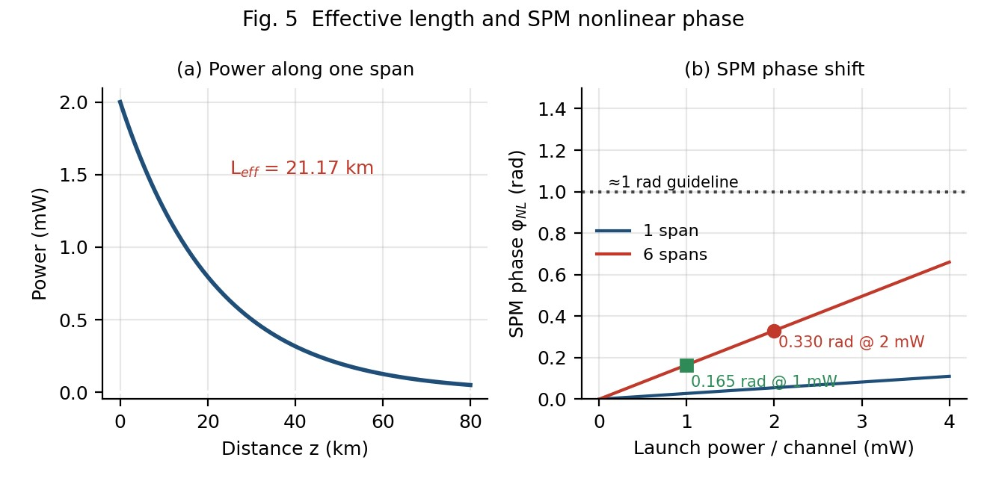
Fig. 5 (a) Signal power along an 80 km span, L_{eff} = 21.17 km; (b) SPM phase versus launch power per
channel for 1 and 6 spans.

4.2 XPM and FWM in a 100 GHz grid
Cross-phase modulation (XPM). Each channel experiences a phase shift from the intensity of every other channel: φ_{XPM} = 2γ P_{j} L_{eff} – twice the SPM value per interferer. With all seven interferers at 2 mW and no walk-off the upper bound is 2 × 1.3 × 14 mW × 21.17 km = 0.77 rad per span (vs 0.055 rad SPM). XPM is reduced by chromatic dispersion because channels walk off from each other: L_{w} = T_{b} / (D Δλ) = 40 ps / (17 ps/(nm·km) × 0.8 nm) = 2.9 km for adjacent channels, far shorter than L_{eff}, so the phase noise averages out but is converted to intensity noise (PM→IM) by dispersion – the dominant crosstalk for 25 Gb/s channels at 100 GHz. XPM grows with total launched power and decreases with channel spacing and dispersion.
Four-wave mixing (FWM). Three channels at f_{i}, f_{j}, f_{k} generate new tones at f_{i}+f_{j}−f_{k}. The efficiency depends on phase mismatch Δβ = 2πλ²D Δf²/c:
Δβ = 2π (1550×10⁻⁹)²(17×10⁻⁶)(10¹¹)² / (2.998×10⁸) = 8.55 km⁻¹; coherence length L_{coh} = 2π/Δβ = 0.73 km L_{eff} η_{FWM} = [α²/(α²+Δβ²)] [1 + 4e^{−αL} sin²(ΔβL/2)/(1−e^{−αL})²] → η = 2.9×10⁻⁵ (−45 dB) for SMF (D = 17);
5.7×10⁻⁴ (−32 dB) for NZ-DSF (D = 4); 3.4×10⁻² (−15 dB) for D = 0.5
Eight equally-spaced channels generate N²(N−1)/2 = 224 mixing products, and for a uniform grid many fall exactly on signal channels, appearing as coherent in-band crosstalk that cannot be filtered. Standard SMF (D = 17) naturally suppresses FWM by phase mismatch, which is why a non-zero local dispersion must be preserved (never operate near the zero-dispersion wavelength with 100 GHz spacing). FWM power scales as P³, so 2 mW → 1 mW cuts it by 9 dB.
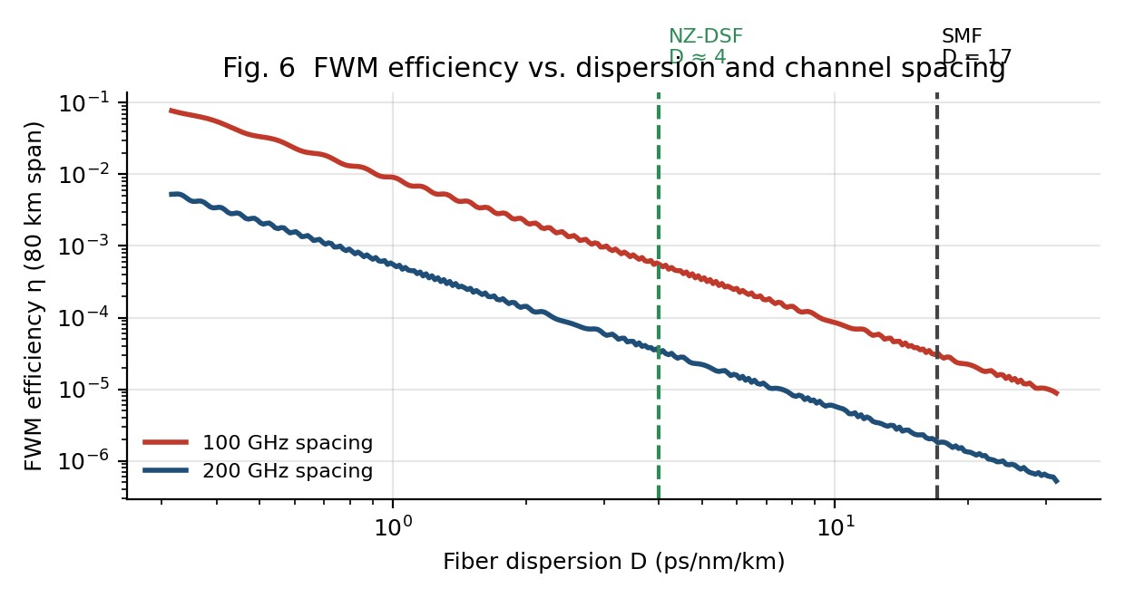
Fig. 6 FWM efficiency versus fiber dispersion for 100 GHz and 200 GHz channel spacing (80 km span).
4.3 SBS and SRS thresholds
SBS: P_{th} ≈ 21 A_{eff}/(g_{B} L_{eff}) = 21 × 80×10⁻¹² m² / (5×10⁻¹¹ m/W × 21.17×10³ m) = 1.68×10⁻⁹ / 1.0585×10⁻
⁶ = 1.59×10⁻³ W = 1.59 mW (+2.0 dBm)
SRS: P_{th} ≈ 16 A_{eff}/(g_{R} L_{eff}) = 16 × 80×10⁻¹² / (6×10⁻¹⁴ × 21.17×10³) = 1.28×10⁻⁹ / 1.270×10⁻⁹ = 1.01 W

(+30 dBm)
Comparison | Value | Result
2 mW per channel vs SBS threshold | 2 mW > 1.59 mW (1.26×;  +1.0 dB) | SBS threshold exceeded for a narrow, unbroadened carrier
1 mW per channel (adopted) vs SBS | 1 mW < 1.59 mW (−2.0 dB) | Below threshold – SBSsafe even for a pure CW line
16 mW total vs SRS threshold | 16 mW  1.01 W (63×; −18 dB) | SRS negligible
8 mW total (adopted) vs SRS | 8 mW  1.01 W | SRS negligible

SRS tilt estimate (assumed flat-top gain over Δν_{R} ≈ 15 THz): ΔP/P ≈ 4.34 g_{R}P_{tot}L_{eff}Δν_{tot}/(A_{eff}Δν_{R}) = 4.34 × 0.254 × (0.7/15) ≈ 0.05 dB per span ≈ 0.3 dB over six spans for 16 mW – negligible, and correctable by gain equalisation.
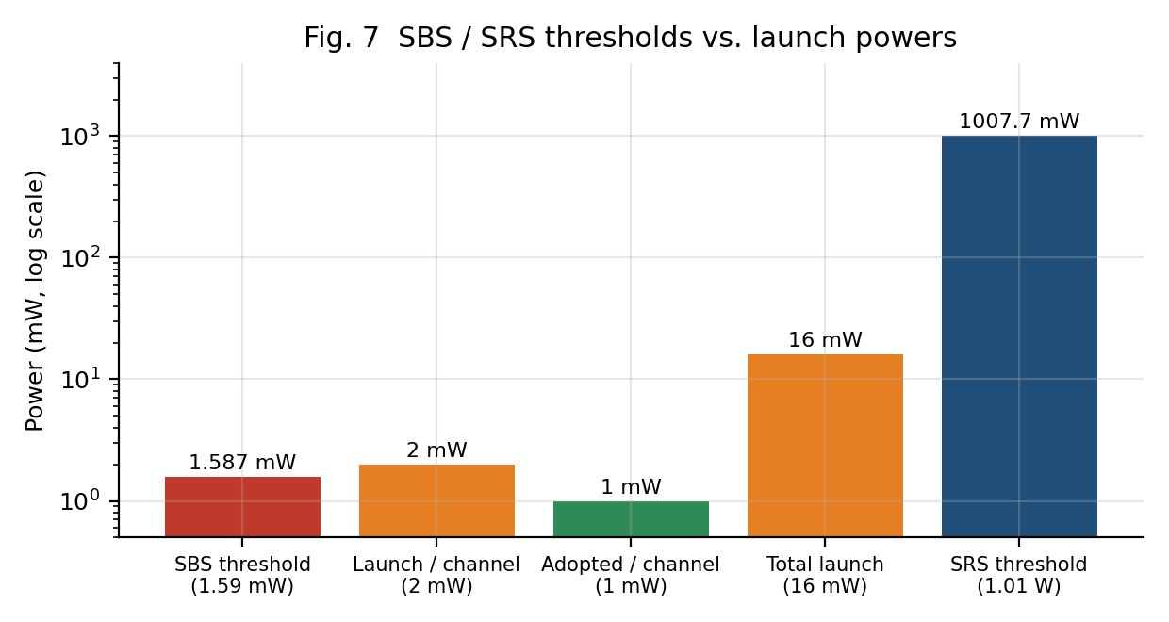
Fig. 7 Launch powers compared with the SBS (1.59 mW) and SRS (1.01 W) thresholds (log scale).
4.4 SBS versus SRS and the role of source linewidth

Table 6. SBS versus SRS
Aspect | SBS | SRS
Physical origin | Scattering from acoustic phonons (electrostriction): a moving index grating Bragg-reflects the signal | Scattering from optical phonons  (molecular vibration of silica)
Direction / shift | Backward only; Stokes shift ≈ 11  GHz (≈ 0.09 nm) | Forward and backward; peak shift  ≈ 13.2 THz (≈ 100 nm)
Gain bandwidth | Very narrow: ≈ 20–100 MHz (A4) | Very broad: ≈ 5–10 THz
Power transfer | Signal power reflected back to the transmitter; saturates received signal and may destabilise the laser | Power transfers from shorter-λ to longer-λ channels (tilt) – like a distributed amplifier
Threshold depends on | Power of each channel (single narrow line); g_{B} ≈ 5×10⁻¹¹ m/W | Aggregate power of all channels;  g_{R} ≈ 6×10⁻¹⁴ m/W
DWDM effect | Per-channel loss + back-reflection noise at ≥ 1.59 mW (the problem here) | Channel-power imbalance when  P_{tot} is hundreds of mW (not here)

Linewidth dependence of SBS: the effective threshold rises as P_{th,eff} ≈ P_{th}(1 + Δν_{s}/Δν_{B}). A DFB of linewidth 2 MHz gives only 1 + 2/20 = 1.1 (1.75 mW), because its line is narrower than the Brillouin bandwidth; the 25 Gb/s NRZ modulation spreads the power over ≈ 25 GHz (1 + 25000/20 ≈ 1250 → ≈ 2 W) but finite extinction leaves a residual narrow carrier, so a design margin is retained by keeping the per-channel power below the unbroadened 1.59 mW (or by phase/frequency dithering of the laser at ≥ 100 MHz).

4.5 Eye-safety check and mitigation methods
Total launch power: P_{tot} = 8 × 2 mW = 16 mW = 10 log(16) = 12.04 dBm
Assumed Class-1 reference limit (A5): 10 mW (+10 dBm) → 16 mW exceeds by 6 mW (2.04 dB).
Adopted 1 mW/ch: P_{tot} = 8 mW = 9.03 dBm → within the reference with 0.97 dB margin.
At 1550 nm the radiation is absorbed in the cornea/aqueous humour (retinal-safe), which is why the Class-1 limit is comparatively high (≈ 10 mW), but 16 mW would require a higher hazard class (Class 1M/3R-type labelling, hazard level control under ANSI Z136.2 / IEC 60825-2), so either the power is reduced or automatic power reduction (APR) and open-fibre control are mandatory.
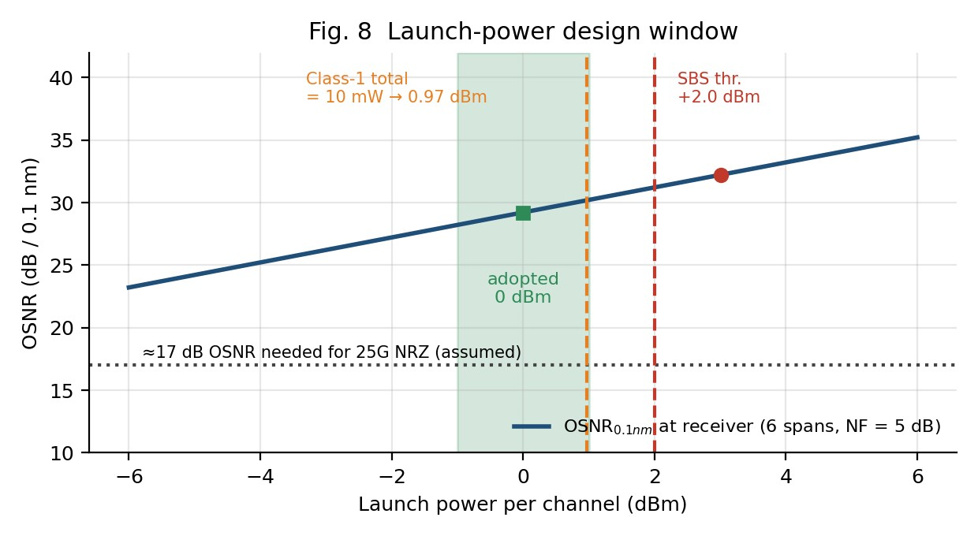
Fig. 8 Launch-power design window: OSNR rises 1 dB/dB, but SBS threshold (+2.0 dBm) and the eyesafety reference (+0.97 dBm per channel for 10 mW total) bound the usable range; 0 dBm is adopted.
OSNR at the receiver, OSNR = 58 + P_{ch} − L_{span} − NF − 10 log N = 58 + 0 − 16 − 5 − 7.78 = 29.2 dB at 1 mW (32.2 dB at 2 mW) versus ≈ 17 dB required – a 12.2 dB margin, so halving the launch power costs only 3 dB of OSNR while reducing φ_{NL} by 50 %, FWM by 9 dB (P³ law) and eliminating SBS.
Two practical methods to reduce nonlinear penalty without cutting received signal level:
- Large-effective-area fibre / lower-NF amplification. Replacing A_{eff} = 80 µm² with ≈ 125 µm² reduces γ to 1.3 × 80/125 = 0.83 W⁻¹km⁻¹ (−36 % φ_{NL}) and raises the SBS threshold to 2.48 mW; combined with distributed-Raman or low-NF EDFAs (≈ 4 dB) the OSNR is maintained at lower launch power.
- Dispersion management with non-zero local dispersion + unequal channel spacing / SBS dithering. A DCM per span (−1360 ps/nm) keeps the local dispersion high (17 ps/nm/km) so XPM and FWM are phase-mismatched and walk-off decorrelates channels, while the accumulated dispersion is reset; a small RF dither of the DFB bias or a phase-modulated carrier broadens the line and raises P_{th}(SBS) without lowering the signal power.

DESIGN DECISION 3. I recommend a launch-power-limited, dispersion-managed nonlinear-control strategy – 1 mW (0 dBm) per channel (8 mW total, +9.03 dBm), per-span DCM or receiver EDC, non-zero local dispersion (SMF, D = 17), SBS dither, optional large-A_{eff} fibre, plus APR/ALS eye-safety protection – because: the SBS threshold (1.59 mW) is lower than the specified 2 mW launch, whereas 1 mW lies 2 dB below it; XPM (≤ 0.77 rad/span bound at 2 mW) and FWM (224 products, P³ dependence) are the real DWDM penalties and scale as P and P³ respectively; SPM is modest (0.165 rad over six spans at 1 mW); SRS (1.01 W) is irrelevant; the 16 mW total exceeds the +10 dBm reference whereas 8 mW does not; and the OSNR remains 12.2 dB above requirement, so the received signal quality is preserved.

STAGE 5 – Soliton Transmission, Digital Back-propagation and Photonic Integration

5.1 Physical balance enabling solitons
In the anomalous-dispersion regime (β₂ < 0, true for SMF at 1550 nm) the leading edge of a pulse travels slower than the trailing edge relative to the carrier, giving a down-chirp that compresses a positively-chirped pulse. Kerr self-phase modulation (n = n₀ + n₂I) imprints exactly the opposite (up-)chirp on the pulse. When the two effects cancel – L_{D} = L_{NL}, i.e. N = 1 – a sech-shaped pulse, u(z,t) = sech(t/T₀) exp(iz/2L_{D}), propagates unchanged. The balance condition is
N² = L_{D}/L_{NL} = γ P₀ T₀² / |β₂| = 1 → P₀ = |β₂| / (γ T₀²) = 1/(γ L_{D})

5.2 Dispersion length and fundamental-soliton power
L_{D} = T₀² / |β₂| = (15 ps)² / (20 ps²/km) = 225 / 20 = 11.25 km
Fundamental soliton: L_{NL} = L_{D} = 11.25 km → P₀ = 1/(γ L_{NL}) = 1 / (1.3 W⁻¹km⁻¹ × 11.25 km) = 0.0684

W = 68.4 mW (18.4 dBm)

5.3 Soliton order at 2 mW and feasibility
L_{NL} = 1/(γ P₀) = 1 / (1.3 × 2×10⁻³ W⁻¹km⁻¹·W) = 384.6 km
N² = L_{D}/L_{NL} = 11.25 / 384.6 = 0.02925 → N = 0.171
Since N 1, dispersion completely dominates (L_{D} is 34× shorter than L_{NL}); the pulse broadens linearly as T(z)/T₀ = √(1+(z/L_{D})²), i.e. by a factor 7.18 after one 80 km span (Fig. 9b). Making the pulse a fundamental soliton would need 68.4 mW peak – 34× (15.3 dB) more than 2 mW. Integration lowers coupling and splice loss (≈ +2–4 dB launched power for the same laser, which directly lifts OSNR), improves wavelength matching because all lasers share the same epitaxial growth and a common TEC, reduces reflections (a source of RIN and SBS-like instabilities), shortens electrical interconnects (higher bandwidth, lower jitter) and lowers power and footprint
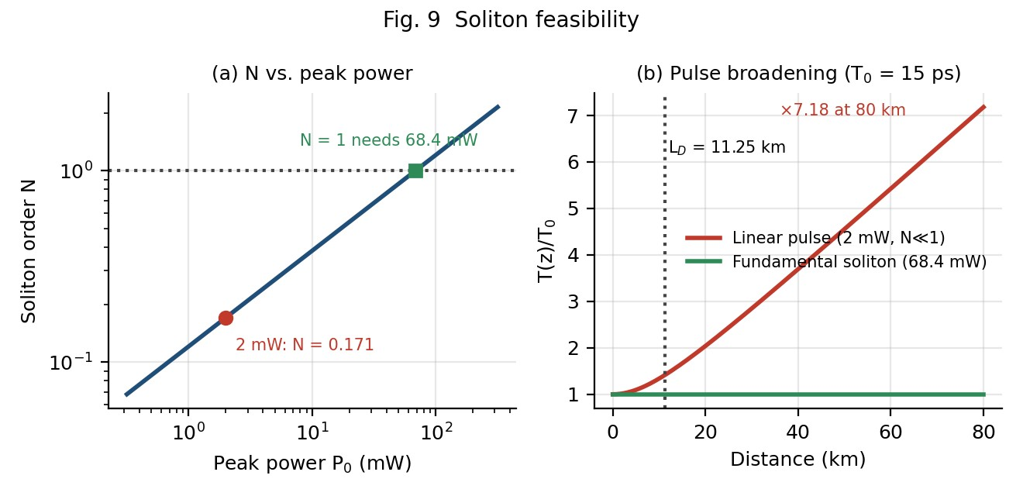
Fig. 9 Soliton feasibility: (a) soliton order N versus peak power – N = 0.171 at 2 mW, N = 1 needs 68.4
mW; (b) pulse broadening over one span.
Further obstacles even if power were available: (i) soliton energy E = 2P₀T₀ = 2.05 pJ, i.e. average power ≈ ½ E R_{b} ≈ 25.6 mW per channel and ≈ 205 mW (+23 dBm) for eight channels – 13 dB above the eye-safety reference and 16× the SBS threshold; (ii) amplifier spacing 80 km = 7.1 L_{D} (soliton period z₀ = πL_{D}/2 = 17.7 km), violating the path-averaged-soliton condition L_{amp}  L_{D}; (iii) bit slot to pulse-width ratio T_{b}/(2T₀) = 40/30 = 1.33, whereas ≥ 5 is needed to avoid soliton–soliton interaction; (iv) Gordon–Haus timing jitter and inter-channel collision-induced frequency shifts in a 100 GHz WDM grid; (v) it requires an RZ pulse source, not NRZ.
Soliton verdict: NOT feasible for this link (N = 0.171, P₀ = 68.4 mW needed vs 2 mW available, 80 km spans, 100 GHz WDM, NRZ format). Conventional dispersion-managed NRZ transmission is chosen.

5.4 Digital back-propagation (DBP)
DBP digitally inverts the fiber: the received complex field is propagated backwards through a virtual fiber (opposite sign of α, β₂, γ) by solving the nonlinear Schrödinger equation ∂A/∂z = −(α/2)A − (jβ₂/2)∂²A/∂t² + jγ|A|²A with the split-step Fourier method – linear steps (chromatic-dispersion all-pass filter) alternating with nonlinear steps (phase rotation by γ|A|²L_{step}) – recovering both the dispersive and the deterministic Kerr distortion (SPM, and XPM/FWM when all channels are co-processed).
• Practical limitations: (1) it needs the full complex field – a coherent receiver with phase and polarisation diversity; our 25 Gb/s NRZ IM-DD link detects only intensity, so the phase needed for DBP is lost; (2) compensation of inter-channel nonlinearity requires joint processing of all eight channels (≈ 800 GHz optical bandwidth, ADCs and DSP at tens of Gs/s per channel, hundreds of watts of DSP); (3) signal–ASE nonlinear interaction, PMD and time-varying polarisation and unknown neighbour-channel data are stochastic and cannot be inverted – single-channel DBP typically yields only ≈ 0.5–1.5 dB; (4) high computational complexity (steps per span × 6 spans).
DBP verdict: NOT appropriate for the complete 8-channel IM-DD link. The dominant penalties (SBS, XPM, FWM, dispersion) are better handled by launch-power control, dispersion management and receiver EDC. DBP becomes relevant only if the link is upgraded to coherent (e.g. DP-QPSK) detection, where singlechannel DBP at the receiver is a viable add-on.
5.5 Standards: parameters and compliance checking

Table 7. Transmitter parameters in the standards and the compliance test plan
Parameter  (G.957 /  802.3bm/bs) | Requirement / typical limit | Proposed transmitter value | How it is verified
Centre wavelength / frequency | ITU grid ± tolerance  (here ±0.1 nm) | 193.1–193.8 THz,  ±0.05 nm | Wavelength meter / OSA over 0–40 °C chamber sweep
Mean launch power | Within specified min–max window;  Class-1 limit | 0 dBm/ch (8 mW =  +9.03 dBm total) | Calibrated power meter, aggregate + per-channel
Spectral width /  SMSR | RMS or −20 dB  width within limit;  SMSR ≥ 30 dB | Single mode, SMSR  > 35 dB | OSA at 0.02 nm resolution
Extinction ratio | ≥ 8.2 dB (G.957 S-64 class), ≥ 3–5 dB  (802.3 NRZ lanes) | ≥ 9 dB (EAM) | Sampling scope /  OMA measurement
Eye mask / TDP  / TDECQ | Mask margin ≥ 0;  TDP/TDECQ ≤ limit | Eye margin > 10 % (B = 17.5 GHz, f_{3dB}(EAM) > 30  GHz) | Sampling scope with  4th-order Bessel– Thomson filter at 0.75  R_{b}
RIN₂₀OMA | ≤ −136 dB/Hz  (802.3bm/bs) | ≈ −145 dB/Hz at I =  3.3 I_{th} | RIN test-set, 20 dB reflection
Return-loss tolerance | ≥ 12–20 dB tolerated | On-chip/inline isolator ≥ 30 dB | Back-reflection injection test
Eye safety | Class 1 (IEC 608251) / ANSI Z136.2 hazard level | 9.03 dBm < 10 dBm;  APR & ALS | Class-1 measurement at open connector, 10 s; APR trip-time test

Note: IEEE 802.3bm lanes at 25.78125 GBd NRZ are consistent with the 25 Gb/s channel used here (B = 18.05 GHz), so the same eye and OMA tests apply; DWDM-specific frequency grid and tolerance are specified by ITU-T G.694.1 (assumed companion reference).
5.6 Discrete vs InP-monolithic vs Si-photonics transmitters

Table 8. Comparison of implementation options (typical industry-level values; assumption A10)
Criterion | Discrete (8 TOSAs  + mux) | Monolithic InP PIC (8  DFB-EAM + AWG) | Si-photonics, hybridintegrated laser
Footprint | ≈ 20–40 cm²; many fibre splices | ≈ 3–6 cm² module; chip  ≈ 5 × 8 mm | ≈ 2–5 cm²; smallest modulators, but external/bonded lasers
Power consumption | ≈ 10–16 W (8 TECs,  8 drivers) | ≈ 4–7 W (one TEC, shared control) | ≈ 3–6 W + laser power; no laser TEC if bonded III-V in thermal path
Coupling / insertion loss | 8 × (1–3 dB) chipto-fibre, + discrete mux 2–3 dB | One output coupler (1–2 dB) with spot-size converter; internal waveguide loss 2–3 dB | Laser-to-Si 1.5–3 dB +  MZM 4–6 dB + fibre 1.5–3 dB; booster usually required
Reliability | Many optical joints/alignments | Fewer joints; mature InP reliability; yield of 8 lasers + 8 EAMs is the risk | CMOS-proven passives; bonding/heterogeneous interface still maturing
Wavelength  stability | Per-laser TEC, best individual control | Common TEC + perchannel heater trim | Si index drift 0.08 nm/°C in rings; needs tight thermal control
Scalability | Poor (linear in cost/size) | Good to 8–16 λ | Best (wafer-scale, 300 mm, co-packaged CMOS drivers)
Suitability here (1550 nm, 8 λ, 2 mW/ch) | OK but bulky/expensive | Best match – native 1550 nm gain, EAM chirp low | Strong alternative, needs more gain to reach 0 dBm/ch

Effect of integration on system performance. Integration lowers coupling and splice loss (≈ +2–4 dB launched power for the same laser, which directly lifts OSNR), improves wavelength matching because all lasers share the same epitaxial growth and a common TEC, reduces reflections (a source of RIN and SBS-like instabilities), shortens electrical interconnects (higher bandwidth, lower jitter) and lowers power and footprint. Its drawbacks are yield compounding (all eight channels must work), thermal crosstalk between lasers on the same chip (managed by the per-channel heater trim and locker) and limited upgrade flexibility.
Power budget (per channel) | Level (dBm) | Power (mW)
DFB laser output (40 mA) | +9.24 | 8.40
EAM insertion loss (−3.5 dB) | +5.74 | 3.75
AWG mux + output coupling (−2.7 dB) | +3.04 | 2.01
VOA/SOA trim to adopted launch (−3.0 dB; headroom for ageing) | 0.0 | 1.00
Aggregate of 8 channels at the booster/line input | +9.03 | 8.0

DESIGN DECISION 4. I recommend a monolithic InP photonic-integrated transmitter (8-λ DFB + EAM array with on-chip AWG multiplexer, SOA/VOA power trim, monitor photodiodes, common TEC and etalon locker), with dispersion compensation (per-span DCM and/or receiver EDC) and no soliton or DBP stage as the transmitter/integration strategy because: native 1550 nm InGaAsP gain gives λ = 1.55 µm, η_{int} = 0.8 and 8.4 mW; the integrated EAM removes the 2.5 GHz-margin bandwidth limit and the chirp problem identified in Stage 3; one coupler and a shared TEC provide the 0.1 °C stability needed against the 4 nm drift with ≈ 6
W instead of > 10 W; the 3 dB headroom in the power budget supports the 0 dBm launch that respects SBS (1.59 mW) and eye safety (≤ 10 mW); soliton transmission is infeasible (N = 0.171) and DBP is inapplicable to IM-DD; and the design satisfies the G.957/802.3bm/bs transmitter parameters. Si-photonics with a hybrid laser is the alternative if volume, CMOS co-packaging or > 16 channels are required.

STAGE 6 – Verification and Critical Evaluation

Table 9. Final verification of the transmitter against the requirement
Requirement | Specified / Target | Achieved | Satisfactory?
Optical source selection | 1550 nm, singlemode, narrow line, SMSR ≥ 30 dB, 8 λ on 100 GHz grid | DFB: λ = 1.55 µm, η_{int} = 0.80, SMSR > 35 dB, MHz linewidth, weighted score 4.50 (best) | YES
Modulation bandwidth and output power | B ≈ 17.5 GHz; OSNR ≥ 17 dB  after 6 spans | f_{3dB} = 20 GHz (margin 2.5 GHz, 14.3 %; EAM > 30 GHz); P = 8.4 mW = 9.24 dBm; 0 dBm/ch launched → OSNR 29.2 dB | YES
Spectral / chirp and wavelength stability | ±0.1 nm over ΔT =  40 °C; low chirp | Uncontrolled 4.0 nm → TEC  ±0.1 °C + locker gives ±0.05 nm  (rss); external modulation α_{H} ≈ 0–  1 | YES (with  TEC)
Nonlinearimpairment control and eye safety | SBS/SRS below  threshold; Σ P ≤ 10 mW (assumed) | P_{th}(SBS) = 1.59 mW > 1 mW; P_{th}(SRS) = 1.01 W  8 mW;  φ_{NL}(6 spans) = 0.165 rad; total  9.03 dBm | YES (at 1 mW; NO at 2 mW – SBS and 16 mW exceed limits)
Soliton / dispersion condition | Dispersion managed over 8160 ps/nm | L_{D} = 11.25 km, N = 0.171 → soliton infeasible; DCM (−1360 ps/nm/span) or EDC used | YES (soliton rejected)
Integration / DSP / standards strategy | G.957, IEEE  802.3bm/bs, ANSI Z136; compact, scalable | InP PIC + common TEC, EDC; DBP rejected for IM-DD; test plan in Table 7 | YES

Consistency check. The calculated values interlock without contradiction: (1) the wavelength and η_{int} follow directly from E_{g}, τ_{r}, τ_{nr}; (2) the 8.4 mW (9.24 dBm) output after 6.2 dB of on-chip loss gives +3.04 dBm, which covers the adopted 0 dBm launch with 3 dB of headroom; (3) the bandwidth margin (2.5 GHz) is small for direct modulation, which is why external modulation was chosen, a decision independently reinforced by the chirp-dispersion estimate (174 ps/span); (4) the 4 nm drift (5 slots) fixes TEC control; (5) the nonlinear analysis shows that the given 2 mW/channel actually violates SBS (1.59 mW) and, as an aggregate, the eyesafety reference (16 mW > 10 mW), so the design deliberately departs from it and quantifies the cost – only 3 dB of OSNR, with 12.2 dB still in hand; (6) the soliton and DBP analyses show that neither can substitute for these measures.
Critical evaluation / limitations. The EAM, AWG and coupling losses, the Class-1 limit and the OSNR requirement are assumptions (A5, A6, A10); real values should be confirmed by measurement. Nonlinear penalty is estimated by analytic phase-shift and threshold metrics, not by a full split-step simulation or Gaussian-noise model; the SBS broadening factor depends on the actual NRZ spectrum and extinction ratio. The 2.5 GHz bandwidth margin for the laser itself is not relied upon because the external modulator carries the data. Residual risks: yield of an 8-laser PIC, thermal crosstalk, and the need for per-span dispersion compensation.
FINAL TRANSMITTER DESIGN – Integrated Engineering Solution

F.1 Final parameter / design table
Parameter | Adopted value
Optical source | 8 × InGaAsP/InP DFB lasers (one per channel), λ/4-shifted grating, SMSR > 35 dB
Channel plan (ITU 100  GHz grid) | 193.1–193.8 THz → 1552.52, 1551.72, 1550.92, 1550.12,  1549.32, 1548.51, 1547.72, 1546.92 nm (spacing 0.80 nm)
Emission wavelength  from E_{g} | 1.24/0.80 = 1.55 µm; η_{int} = 0.80; η_{d} = 37.5 %
Bias / threshold / slope | I_{bias} = 40 mA (I/I_{th} = 3.33), I_{th} = 12 mA, η_{s} = 0.3 mW/mA
Laser output power | 8.4 mW (+9.24 dBm) per channel
Modulator / data rate | Integrated EAM (or MZM), 25 Gb/s NRZ (25.78 GBd for  802.3 lanes), α_{H} ≈ 0–1, ER ≥ 9 dB, f_{3dB} > 30 GHz
Bandwidth | B = 17.5 GHz required; laser f_{3dB} = 20 GHz (margin 2.5 GHz); modulator > 30 GHz
Launch power | 1 mW (0 dBm) per channel, 8 mW total (+9.03 dBm); stress case 2 mW only with SBS dither and APR
TEC setting | T_{set} = 25 °C, stability ±0.1 °C (±0.01 nm); wavelength locker accuracy ±0.03 nm; total ≤ ±0.05 nm (< ±0.1 nm)
Link | 6 × 80 km SMF (α = 0.2 dB/km), EDFA per span (NF 5 dB),  DCM −1360 ps/nm per span or receiver EDC
Nonlinear metrics | L_{eff} = 21.17 km; φ_{NL} = 0.0275 rad/span, 0.165 rad total; SBS thr. 1.59 mW; SRS thr. 1.01 W
Soliton check | L_{D} = 11.25 km; P₀ = 68.4 mW; L_{NL}(2 mW) = 384.6 km; N =  0.171 → not feasible
Safety / standards | ITU-T G.957 (G.694.1 grid), IEEE 802.3bm/bs, ANSI  Z136.2/IEC 60825-1 Class-1 reference, APR/ALS
Implementation | Monolithic InP PIC (8 DFB-EAM + AWG + SOA/VOA + monitor PDs), single TEC with per-channel heater trim

F.2 Block diagram
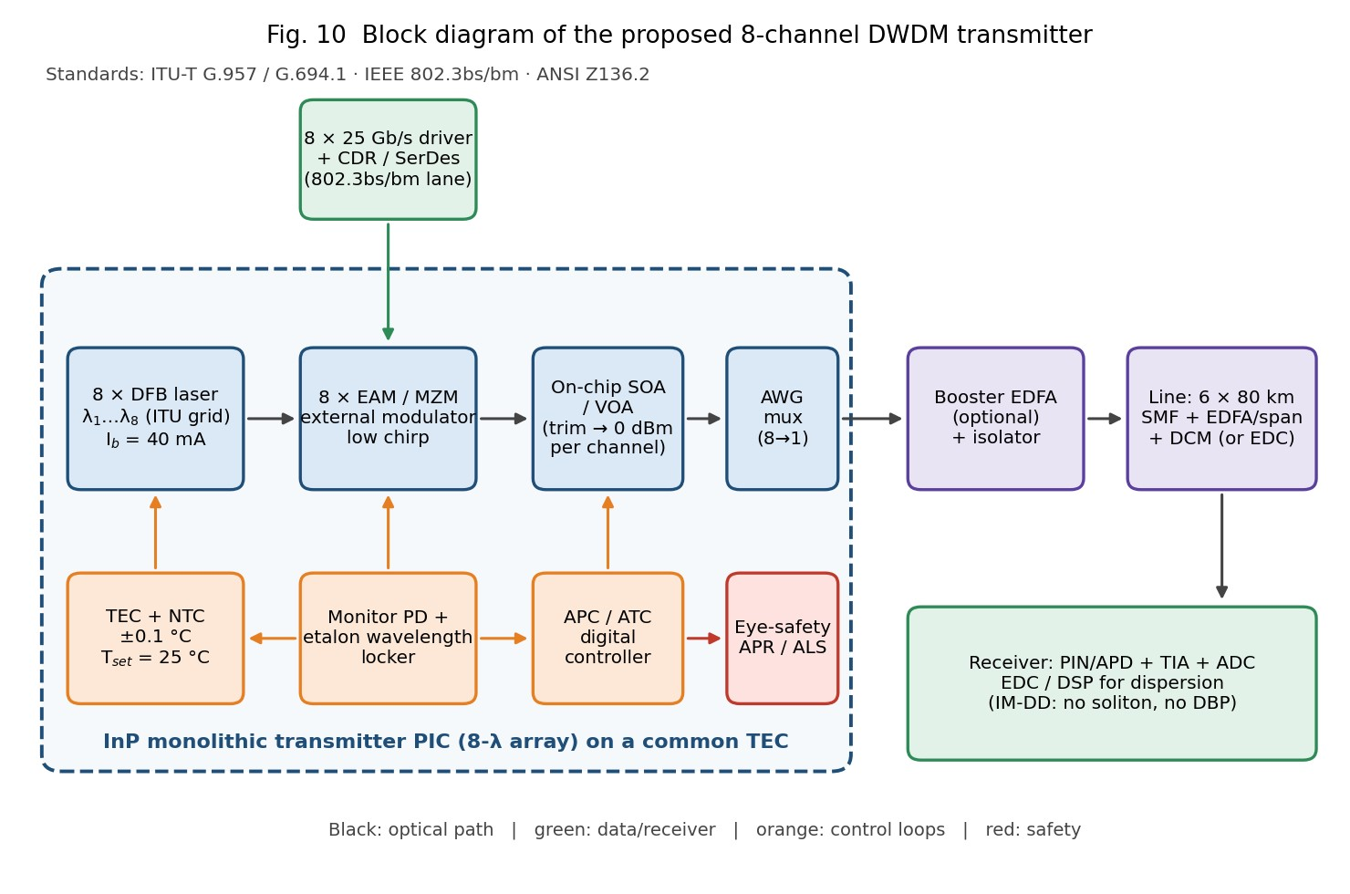

F.3 How the design choices work together
- Source + modulation: DFB for spectral purity, EAM for speed and low chirp – their combination keeps each signal inside its 0.8 nm slot and makes dispersion compensation deterministic.
- Wavelength control: 4.0 nm uncontrolled drift is removed by TEC (±1 °C needed, ±0.1 °C adopted) with an etalon locker closing the loop on the monitor photodiode.
- Nonlinear / eye-safety strategy: 1 mW per channel keeps P below the SBS threshold (1.59 mW), the aggregate below +10 dBm, φ_{NL} at 0.165 rad, and FWM 9 dB lower than at 2 mW while still giving ≈ 29 dB OSNR; non-zero local dispersion and DCM suppress XPM/FWM; APR/ALS protects against open-fibre exposure.
- Integration: InP monolithic integration minimises coupling loss and component count, supplies the 3 dB power headroom and fits the standards test plan; Si-photonics is the scale-up path.
- Compensation: receiver-side EDC/DCM for dispersion; neither soliton transmission (N = 0.171) nor DBP (IM-DD, no phase) is included.

F.4 Final engineering recommendation
Deploy an InP-integrated, TEC-stabilised, wavelength-locked 8-channel DFB + EAM transmitter on the 100 GHz ITU grid at 1550 nm, launching 0 dBm per channel (8 mW total) into dispersion-managed 6 × 80 km SMF spans, with APR/ALS eye-safety control. Upgrade paths: QD comb or uncooled QD sources, large-A_{eff} fibre to allow higher launch power, and coherent detection with single-channel DBP for higher-order formats.
FINAL ENGINEERING DECISION

WOULD YOU DEPLOY THE TRANSMITTER SOLUTION YOU CREATED? ➜ YES – with
technical justification and conditions.
- Source selection: λ = 1.55 µm, η_{int} = 0.80, 8.4 mW (9.24 dBm), SMSR > 35 dB, highest weighted score (4.50) – requirement met.
- Modulation bandwidth: 17.5 GHz required vs 20 GHz laser (margin 2.5 GHz) and > 30 GHz EAM; chirp problem removed by external modulation – met.
- Wavelength stability: 4.0 nm uncontrolled drift (5 channel spacings) reduced to ≤ ±0.05 nm by ±0.1 °C TEC + locker – within ±0.1 nm.
- Nonlinearity: SBS threshold 1.59 mW, SRS 1.01 W, φ_{NL} = 0.165 rad (1 mW), XPM/FWM controlled by dispersion management and power – met only at the adopted 1 mW/channel; the given 2 mW/16 mW case is rejected.
- Soliton / compensation: N = 0.171 (needs 68.4 mW) and IM-DD detection rule out solitons and DBP; DCM/EDC used – consistent.
- Standards and integration: G.957, IEEE 802.3bm/bs and ANSI Z136 parameters addressed with a defined test plan; InP integration gives compactness, ≈ 6 W power and scalability.
Conditions for deployment: (1) launch ≤ 1 mW/channel (≤ +9.03 dBm total) unless SBS dither and a higher hazard-class procedure are implemented; (2) TEC ±0.1 °C and locker active before enabling data; (3) per-span DCM or receiver EDC; (4) type-test of SMSR, TDECQ/eye mask and Class-1 measurement before shipment.

Mapping of the Solution to Course Outcome
CO element | Where addressed | Evidence / graph
Operation and principles of  LED, FP, DBR, DFB, VCSEL,  QD sources | Stage 2 (2.1–2.6) | Table 2, decision matrix, Fig.  1 (L–I), Fig. 2 (spectra)
Efficiency (η_{int}, η_{d}, wall-plug) | Stage 2.1 | 0.80, 37.5 %, 14 %
Modulation dynamics (rate  equations, f_{r}, small/large signal, chirp) | Stage 3 (3.3–3.4) | Fig. 3, Tables 3–4
Spectral stability and temperature control | Stage 3.5 | Fig. 4, Table 5
SPM, XPM, FWM, SBS, SRS | Stage 4 | Figs. 5, 6, 7, 8
Soliton transmission and DBP | Stage 5.1–5.4 | Fig. 9
Photonic integration and its effect on system performance | Stage 5.5–5.6, Final design | Table 8, power budget, Fig.  10

References
- G. P. Agrawal, Fiber-Optic Communication Systems, 4th ed., Wiley – nonlinear effects, solitons, rate equations.
- G. Keiser, Optical Fiber Communications, 5th ed., McGraw-Hill – sources, modulation, WDM design.
- J. Senior, Optical Fiber Communications: Principles and Practice, 3rd ed., Pearson – LEDs, laser diodes, integrated optics.
- L. A. Coldren, S. W. Corzine, M. Mašanović, Diode Lasers and Photonic Integrated Circuits, 2nd ed., Wiley.
- ITU-T Recs. G.957 (SDH optical interfaces), G.694.1 (DWDM frequency grid), G.692; IEEE Std 802.3bm-2015, 802.3bs-2017; ANSI Z136.2; IEC 60825-1/-2.

